IMPROVING THE PERFORMANCE OF GRANT FUNDED SUSTAINABLE RESEARCH PROJECTS

Mishu Pham-Whipple, Program on the Environment, University of Washington
Site supervisor: Elise Glassman, Project Manager, UW Sustainability
Faculty advisor: Jan Whittington, Department of Urban Design and Planning, University of Washington
Host Organization: UW Sustainability: Green Seed Fund

In response to climate change, many cities and institutions, are developing ways to make their infrastructure and services more sustainable. The transition to a more sustainable society, however, requires capital (Faghihi, 2014). A funding strategy often used for sustainable development is through grants (Bäckstrand, 2006). The purpose of this study was to find ways to improve funding decisions in the future so that grant money can be spent efficiently while maximizing its impact on sustainability. To accomplish this, I interviewed past project teams that were funded by the Green Seed Fund about their projects, their experience through the grant process, and their plans for the future. I was able to identify distinct categories that projects fell under: investigative research, education and infrastructure, and created recommendations related to each type of category of research project, involving how the fund holds the projects accountable. For projects with an investigative research component, a plan for the future of their research results should be documented. For projects with a permanent infrastructure component, a plan for long term maintenance and coordination with facilities should be documented. For projects with an education component, a plan for an evaluation process should be documented. With these additions to the grant application and accountability process, the sustainability impact of funded projects can be improved, giving institutions, such as research universities, yet another strategy to improve sustainability to combat climate change, while on a budget.

Introduction
Cities are home to more than half of the world’s population and a contributor to about 70% of the world’s carbon dioxide emissions, making cities key to addressing and adapting to climate change (The World Post 2015). In response to climate change, many cities and institutions are developing ways to make their infrastructure and services more sustainable (Dias 2001). The United Nations, most international organizations, academic scholars and policy analysts acknowledge the importance of universal Sustainable Development Goals (SDGs) (Joshi 2015). The transition to a more sustainable society, however, requires capital (Faghihi 2014). A common way institutions fund sustainable development projects are through grants, or a sum of money typically given by a party, for a specific project, with a set of conditions (Bäckstrand 2006) (figure 1).
The pressure to provide results and prove performance in response to the interests of outside funding has a large influence on the structure and administration of universities. As a result of this pressure, metrics are widely used by universities and other institutions. To quantify sustainability, a strategy typically used is Sustainability Indicators (SIs). SIs are a set of quantifiable metrics that allow people to compare progress towards sustainability through data that can be easily and cheaply collected. However a drawback to this strategy is that its reductionist nature may oversimplify what sustainability is, which in reality is a complex system (Bell 2001). Sustainability indicators also do not easily allow for a comparison of sustainable research projects. Creating my own set of sustainability metrics was not an option because even the research projects were difficult to compare to each other.
The pattern of the utility maximizing approach by universities to serve economic development and success through short-term research to fulfill practical knowledge forces universities to operate under competitive market circumstances and has overtaken the traditional research approach characterized by long-term research and research that brings new paradigms (Tammi 2009). The managerial practice of reporting measurements of productivity and the constant search for efficiency, adheres to principles of the for profit sector, which is not necessarily suited for the university model (Lucas 2006). Although this may not seem like the ideal way to conduct academic research, this is the framework that we are working in and as such, we must make the most of it by improving the performance of the work done in terms of quality and efficiency.
The Green Seed Fund and the administration of the University of Washington, as well as administrations everywhere seek to continuously improve efficiency, performance, and savings (Tammi 2009). Because of this interest in the bottom line, the findings and recommendations from my research would be of their interest. Financial resources are limited and even more so for sustainability projects (Wang 2014) therefore getting the most out of funded projects is crucial to efficiency. Maximizing the impact on sustainability will not only reduce our impact on climate change through the reduction of waste, water and energy usage, but also set an example for environmental stewardship and promote societal changes.

The Green Seed Fund
One example of a grant that funds sustainably focused projects is the Green Seed Fund at the University of Washington (UW Sustainability 2015) (figure 3). The fund’s goal is to foster academic research and promote campus sustainability goals, which are found in the university’s Climate Action Plan. There are several requirements to apply for GSF funding. One requirement is to have an interdisciplinary research team consisting of at least one student, one faculty member, and one staff member. The fund’s goal of having interdisciplinary research teams to encourage collaboration are better suited for solving “real world challenges” because of the range of skills and knowledge that each team member brings, which are necessary to solve more complex issues (Dodson 2010). The edge that interdisciplinary research teams have for problem solving allows for universities to have great potential to be change agents within society rather than the traditional knowledge transfer and generation institutions (Peer 2013). As for ensuring the accountability of projects, the GSF requires teams to receive approval from appropriate facilities in their proposal, completion of mid year reports and year end reports, and a final presentation to the Environmental Stewardship Committee. Requirements like these are common across grant funds to ensure feasibility and accountability. As part of my capstone experience, I completed an internship as the Project Coordinator of the fund, where I essentially assisted in managing the fund. Coming into my internship, I wanted to understand how the fund could improve funding decisions in the future so that money was being spent more efficiently while maximizing its impact on sustainability.

Research Question
How do we improve the performance of sustainability research funding, using the Green Seed Fund as a case study?

My Internship
As the Project Coordinator of the fund, I was responsible for assisting in the management of the fund throughout the application process. Responsibilities included reviewing the proposals of applicants, communicating with proposal teams to make sure applications and budgets were complete, setting up meetings with the board of directors and proposal teams, sending award letters to funded projects administering midyear and year end reports, and writing articles about past and present research projects for social media. Making sure the grant application process runs smoothly is important for the GSF to be seen as a professional and legitimate grant that deserves continued funding. Writing articles about GSF projects posted by UW Sustainability is important to engaging and educating the community. Helping to build a reputation for the organization through outreach helps familiarize the community with UW Sustainability, the GSF, and their goals, and ultimately develop the discourse of sustainability and climate change within the community. Social media publicity will directly help to attract future grant applicants and as a result, perpetuate the improvement of sustainability.

Research
In conjunction with my internship, I conducted my own research to see how the performance of sustainability projects could be improved (figure 2). Instead of using a set of sustainability indicators, I Interviewed six past project teams, four through phone conference and two in person, to understand their project, their experience with the GSF, the project’s impact and the team’s plans for the project’s future. Interviews of the teams revealed much more information about potential areas of improvement than the required midyear and year end reports. From the interviews, I formulated recommendations to ensure similar projects in the future would make the most out of their effort and resources. These recommendations correlate to each type of research project and involve how the fund can hold the project teams accountable. I was able to identify three categories that the projects fell under; investigative research, education, and infrastructure (figure 4). The categories represent soft and hard infrastructure. The nature of sustainability necessitates a need for soft infrastructure, in the form of specialized staff or education programs and hard infrastructure, in the form of capital projects or technology (Hawkins 2015). Having funded projects represent both soft and hard infrastructure indicates that sustainability is being approached from multiple angles.

Project Category: Investigative Research
All projects have some level of investigative research. Ones in this category were exclusively research based, while the other categories expanded on their initial research. For projects exclusively based on investigative research, a plan for research results produced would greatly advance the work the team has already done. The two investigative research projects, Reuse of Durable Medical Equipment (DME) and UW Tacoma Husky Lines, were able to identify significant barriers to sustainability through their research. As these teams are now knowledgeable about the problem, they are also the appropriate people to know about realistic solutions. Naturally, these teams laid out some recommendations to these issues when discussing the implications of their research. However, their recommendation are not likely to go far in bringing about a significant change without specific blueprints and identification of key individuals or groups to hand these blueprints to.
An example of this is the Durable Medical Equipment project. The team was able to identify barriers of reuse of DME and identify that the most practical solution at this point is to expand the local reuse organizations and build better connections between them, patients, and physicians. By teams taking one more step in their project to create blueprints for others to carry out a plan for a solution, the findings of the research projects are much more likely to manifest in a change and improve sustainability. Project teams produce findings that fill the information need that policy makers have that prevents them from taking action. Without this information provided by researchers, policy makers do not have evidence that the current policies should be reevaluated and altered (Ingram 2008). My recommendation for teams to identify key figures to mobilize a solution works to close the gap between researchers and policy makers.

Project Category: Infrastructure
Projects with an infrastructure component leave a physical legacy one the project is complete and funding is cut off. Although the GSF and similar grants require that projects get approval from appropriate facilities and maintenance staff, who is responsible in the long run is not necessarily made clear. Operation and maintenance are key to enhancing the sustainability of existing structures (Sohail 2005). When it comes to city infrastructure such as pipes and bridges, maintenance management policies are required (Meegoda 2015). I suggest that same concept be applied to the infrastructure that is related to grant funded projects to enhance their sustainability.
As an example, the Green Wall was built in 2013 and used for research and education through several rounds of funding from both the UW Campus Sustainability Fund and the Green Seed Fund. The Green Wall has been the project with the biggest price tag for the Campus Sustainability Fund yet is a monumental example of sustainable infrastructure and is used as a teaching tool for classes year after year. However, the most recent round of funding from the GSF is coming to a close, but the wall is to remain. The future of how the wall will be used is fuzzy as a source for long term funding for maintenance has not been confirmed. Another example of the problem of long term maintenance of infrastructure created through funded projects is the E-Waste project. Part of the team’s strategy to reduce electronic waste was to install recycling stations in departments with heavy electronic use on campus. However, once funding for the year long project is cut, who will maintain these e-waste bins is up in the air. The team voiced that they would like to continue the programs they started but it would be on a volunteer basis. To ensure that projects involving long term infrastructure have a future with dignity rather than neglect, I propose that these type of projects include a plan for either the maintenance or the dismantling of the infrastructure once the project is complete.

Project Category: Education
The third category of projects are ones with an educational component. Projects with educational programs produce a feeling of really leaving an impression on students and are a great way to include students in sustainability goals. However, to justify further support of the educational programs or similar ones in the future, the programs should be carefully evaluated. Evaluation should happen early in program building, rather than solely as a post implementation exercise (Gooler 1977). The education based projects should go through an evaluation process to identify areas of strengths, areas in need of improvement, and metrics to measure success.
An example is the E-Waste team who created an e-waste education program through engineering and jewelry making workshops for kids. The programs may or may not have left a lasting impact on the kids’ understanding of the problem of e-waste. Given, the workshops were a hit with the kids and deemed a success, a plan to measure the educational impact of the program, through a facilitated discussion or survey, would greatly improve the effectiveness of the project.
In the future, the GSF and similar funds may be more satisfied with results from projects involving educational programs that identify metrics for success early in the program development and evaluate these metrics throughout the process of the program.

Significance
After conducting interviews of past research teams that were funded by the Green Seed Fund, I was able to identify areas in need of improvement. Recommendations for how the fund holds the project teams accountable were made based on the type of project: investigative research, infrastructure, and/or education. For projects with an investigative research component, a plan for the future of their research results should be documented. For projects with a permanent infrastructure component, a plan for long term maintenance and coordination with facilities should be documented. For projects with an education component, a plan for an evaluation process should be documented. With these additions to the grant application and accountability process, the sustainability impact of funded projects can be improved, and not only reduce our impact on climate change, but also promote larger societal changes by being a hub of innovation in sustainability. Further research on how to best market funded projects would greatly benefit the fund and affected communities. Having stronger outreach would help promote the goals of the funds and garner financial and community support. With sustainability at the top of the agenda for world leaders and institutions, improving the performance and financial support of sustainability projects is a natural step in the right direction.

Acknowledgements
First and foremost, my mother, who has worked so hard and sacrificed so much to push me to be the best I can be. I would be nothing without her. My appreciation of her grows daily.
And my dad for showing me what a beautiful world we live in and showing me how to stick it to the man.

Works Cited
Bäckstrand K. Multi-stakeholder partnerships for sustainable development: rethinking legitimacy, accountability and effectiveness. 2006;16(5):290–306.
Bell S, Morse S. Breaking through the Glass Ceiling: Who really cares about sustainability indicators? 2001;6(3):291–309.
Dias-Sardinha I, Reijnders L. Environmental performance evaluation and sustainability performance evaluation of organizations: an evolutionary framework. 2001;8(2):71–79.
Dodson M, Guan L, Fernyhough M, Mir P, Bucci L, Mcfarland D, Novakofski J, Reecy J, Ajuwon K, Thompson D, et al. Perspectives on the formation of an interdisciplinary research team. 2010;391(2):1155–1157.

Faghihi V, Hessami AR, Ford DN. Sustainable campus improvement program design using energy efficiency and conservation. 2015;107:400–409.
Gooler DD. Criteria for Evaluating the Success of Nontraditional Postsecondary Education Programs. 1977;48(1):78.

Hawkins CV, Krause RM, Feiock RC, Curley C. Making meaningful commitments: Accounting for variation in cities investments of staff and fiscal resources to sustainability. 2015;53(9):1902–1924.

Ingram J, Gregory P, Izac A-M. The role of agronomic research in climate change and food security policy. 2008;126(1-2):4–12.

Joshi DK, Hughes BB, Sisk TD. Improving Governance for the Post-2015 Sustainable Development Goals: Scenario Forecasting the Next 50years. 2015;70:286–302.

Lucas, Lisa. 2006. The Research Game In Academic Life. New York: McGraw-Hill Education.

Meegoda JN, Zou Z. Long-Term Maintenance of Culvert Networks. 2015;6(4):04015003.

Peer V, Stoeglehner G. Universities as change agents for sustainability – framing the role of knowledge transfer and generation in regional development processes. 2013;44:85–95.

Sohail M, Cavill S, Cotton AP. Sustainable Operation and Maintenance of Urban Infrastructure: Myth or Reality? 2005;131(1):39–49.

Tammi T. The competitive funding of university research: the case of Finnish science universities. 2008;57(5):657–679.

The World Post: Why Cities Will Be Vital Players at Paris Climate Talks [Internet] (2015) [cited 20 November 2015] Available from http://www.huffingtonpost.com/michael-bloomberg/paris-climate-talks-bloomberg_b_7683246.html
UW Sustainability: Green Seed Fund Grants (2015). [cited 10 November 2015] Available from https://green.uw.edu/green-seed-proposals
Wang X, Hawkins C, Berman E. Financing Sustainability and Stakeholder Engagement: Evidence from U.S. Cities. 2014;50(6):806–834.

Visuals
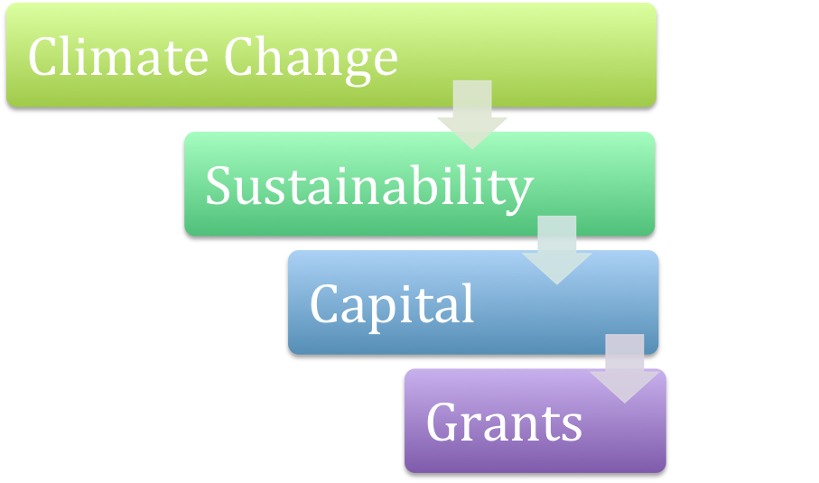
(figure 1) This flowchart helps visualize the context of my research. Grants are a common way sustainable development projects are funded. Sustainable development is increasingly on the agenda of international organizations to combat climate change.
(figure 2) This helps visualize the process I took to answer my research questions.

(figure 3) The Green Seed Fund - Through Green Seed Fund grants, the UW seeks to engage faculty, students, and staff in opportunities that advance sustainable research while contributing to campus sustainability goals.

TYPES OF FUNDED PROJECTS
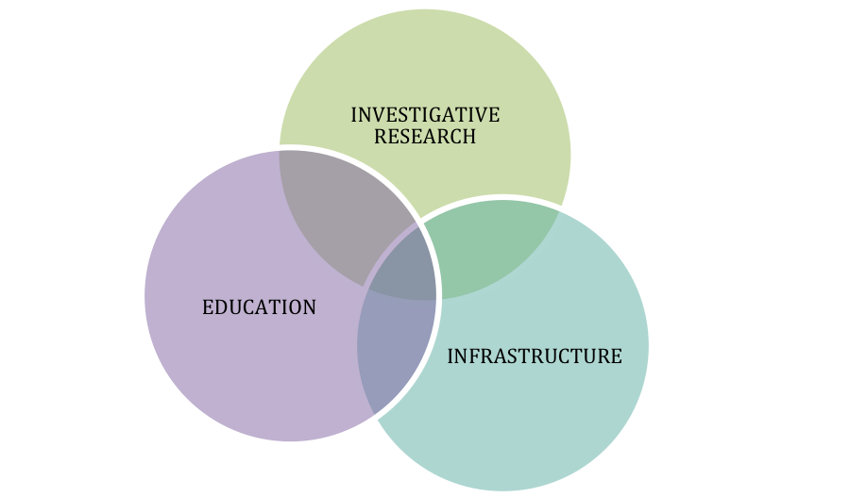
(figure 4) This diagram helps visualize the types of funded projects. All projects have some level of investigative research.

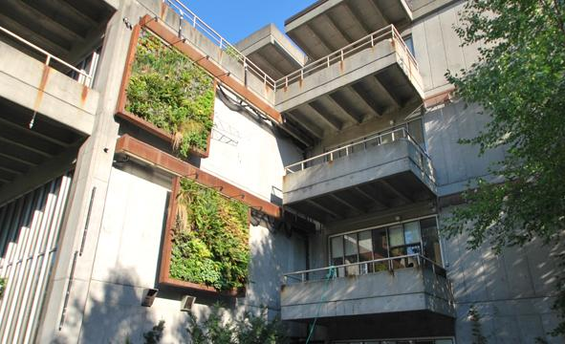
(figure 5) The UW Biodiversity Green Wall - The wall, on the side of Gould Hall on the Seattle Campus, was built to study the potential benefits of green walls. The wall has been through several rounds of funding through the Green Seed Fund and the Campus Sustainability Fund. The future of the Green Wall is uncertain since a source for long term funding is unclear.

Appendix of Deliverables
Deliverable | Recipient | Description
Annotated Bibliography | P. Sean McDonald  Jan Whittington | An annotated bibliography of sources to be used in my capstone synthesis paper.
Two Memoranda | P. Sean McDonald | Memos describing internship progress and reflection.
Post on Capstone Tumblr | P. Sean McDonald | A post to update P.Sean and fellow students about my capstone experience.
Six Articles Based on Interviews Conducted | Elise Glassman, UW Sustainability | These articles are posted to familiarize the community with GSF and funded projects.
Sample of Award Letter to Project Team From GSF | P. Sean McDonald | The award letter is sent to teams who receive funding. The sample shows the type of documents I created and sent out.
Sample of Scoring Matrix for Committee From GSF | P. Sean McDonald | The scoring matrix shows criteria that the decision committee used when viewing proposals. This is an example of the documents between the GSF and the committee.
Sample of Committee’s Scores Matrix For GSF Use | P. Sean McDonald | The committee’s scored matrix was used by the GSF to organize committee responses to proposals.

