Analysis of District Energy in Mount Baker

Background

What is District Energy?

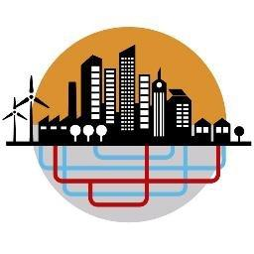
District energy represents a range of technologies that integrate heating and cooling systems for a neighborhood or community. District energy systems (DES) produce steam, hot water or chilled water at a central facility, which is then connected underground through pipe systems to individual buildings for space heating, domestic hot water heating and/or air conditioning. This allows individual buildings to function without their own boilers or furnaces, chillers or air conditioners, resulting in more energy efficient districts. Simply put, energy is shared between buildings and circulated from areas with excess heated or cooled air to areas that are lacking.

When successfully implemented, the environmental and economic benefits of a DES are huge. Implementation, however, requires a significant level of planning and engineering. Because of the expertise and infrastructure required to implement the project, the systems are capital intensive and require substantial investments not only in the initial stages of the project, but also for construction, business development, design, and contract negotiation. Financing tools such as energy service contracts, third party financing, grants, reserve funds, “green funds”, and loans are often used by institutions implementing large scale DES. Private firms are increasingly playing a larger role in financing DES projects, creating more financing options for entities pursuing a DES. These private firms, such as Corix or Veolia Energy North America, have the expertise to design and operate a DES, but inherently operate the system with a for-profit model. Financing smaller scale systems, such as one involving the UW Consolidated Laundry facility, however, are more challenging to finance through private energy firms and instead require a more customized financing arrangement. Smaller DES projects often rely heavily on grant funds.
Another major requirement of a DES is building density. Building density in the system is a significant consideration because this factor influences the cost of the pipe and network infrastructure, affecting the overall cost-benefit outcome. For many major institutional campuses, such as universities, military bases, or medical centers, district energy is regarded as a preferred heating and cooling method. These institutions are ideal hosts of DES due to high building density and consistency in building ownership, which allows for easier implementation.
In addition to current building density, future building density must also be taken into consideration so that arrangements can be made to potentially incorporate new buildings into the system. Moreover, further consideration into what types of buildings are in/will be in the DES, for example, commercial or residential, must be taken into account to evaluate the energy demand on the system at different times of day, and ultimately provide an accurate cost-benefit calculation.

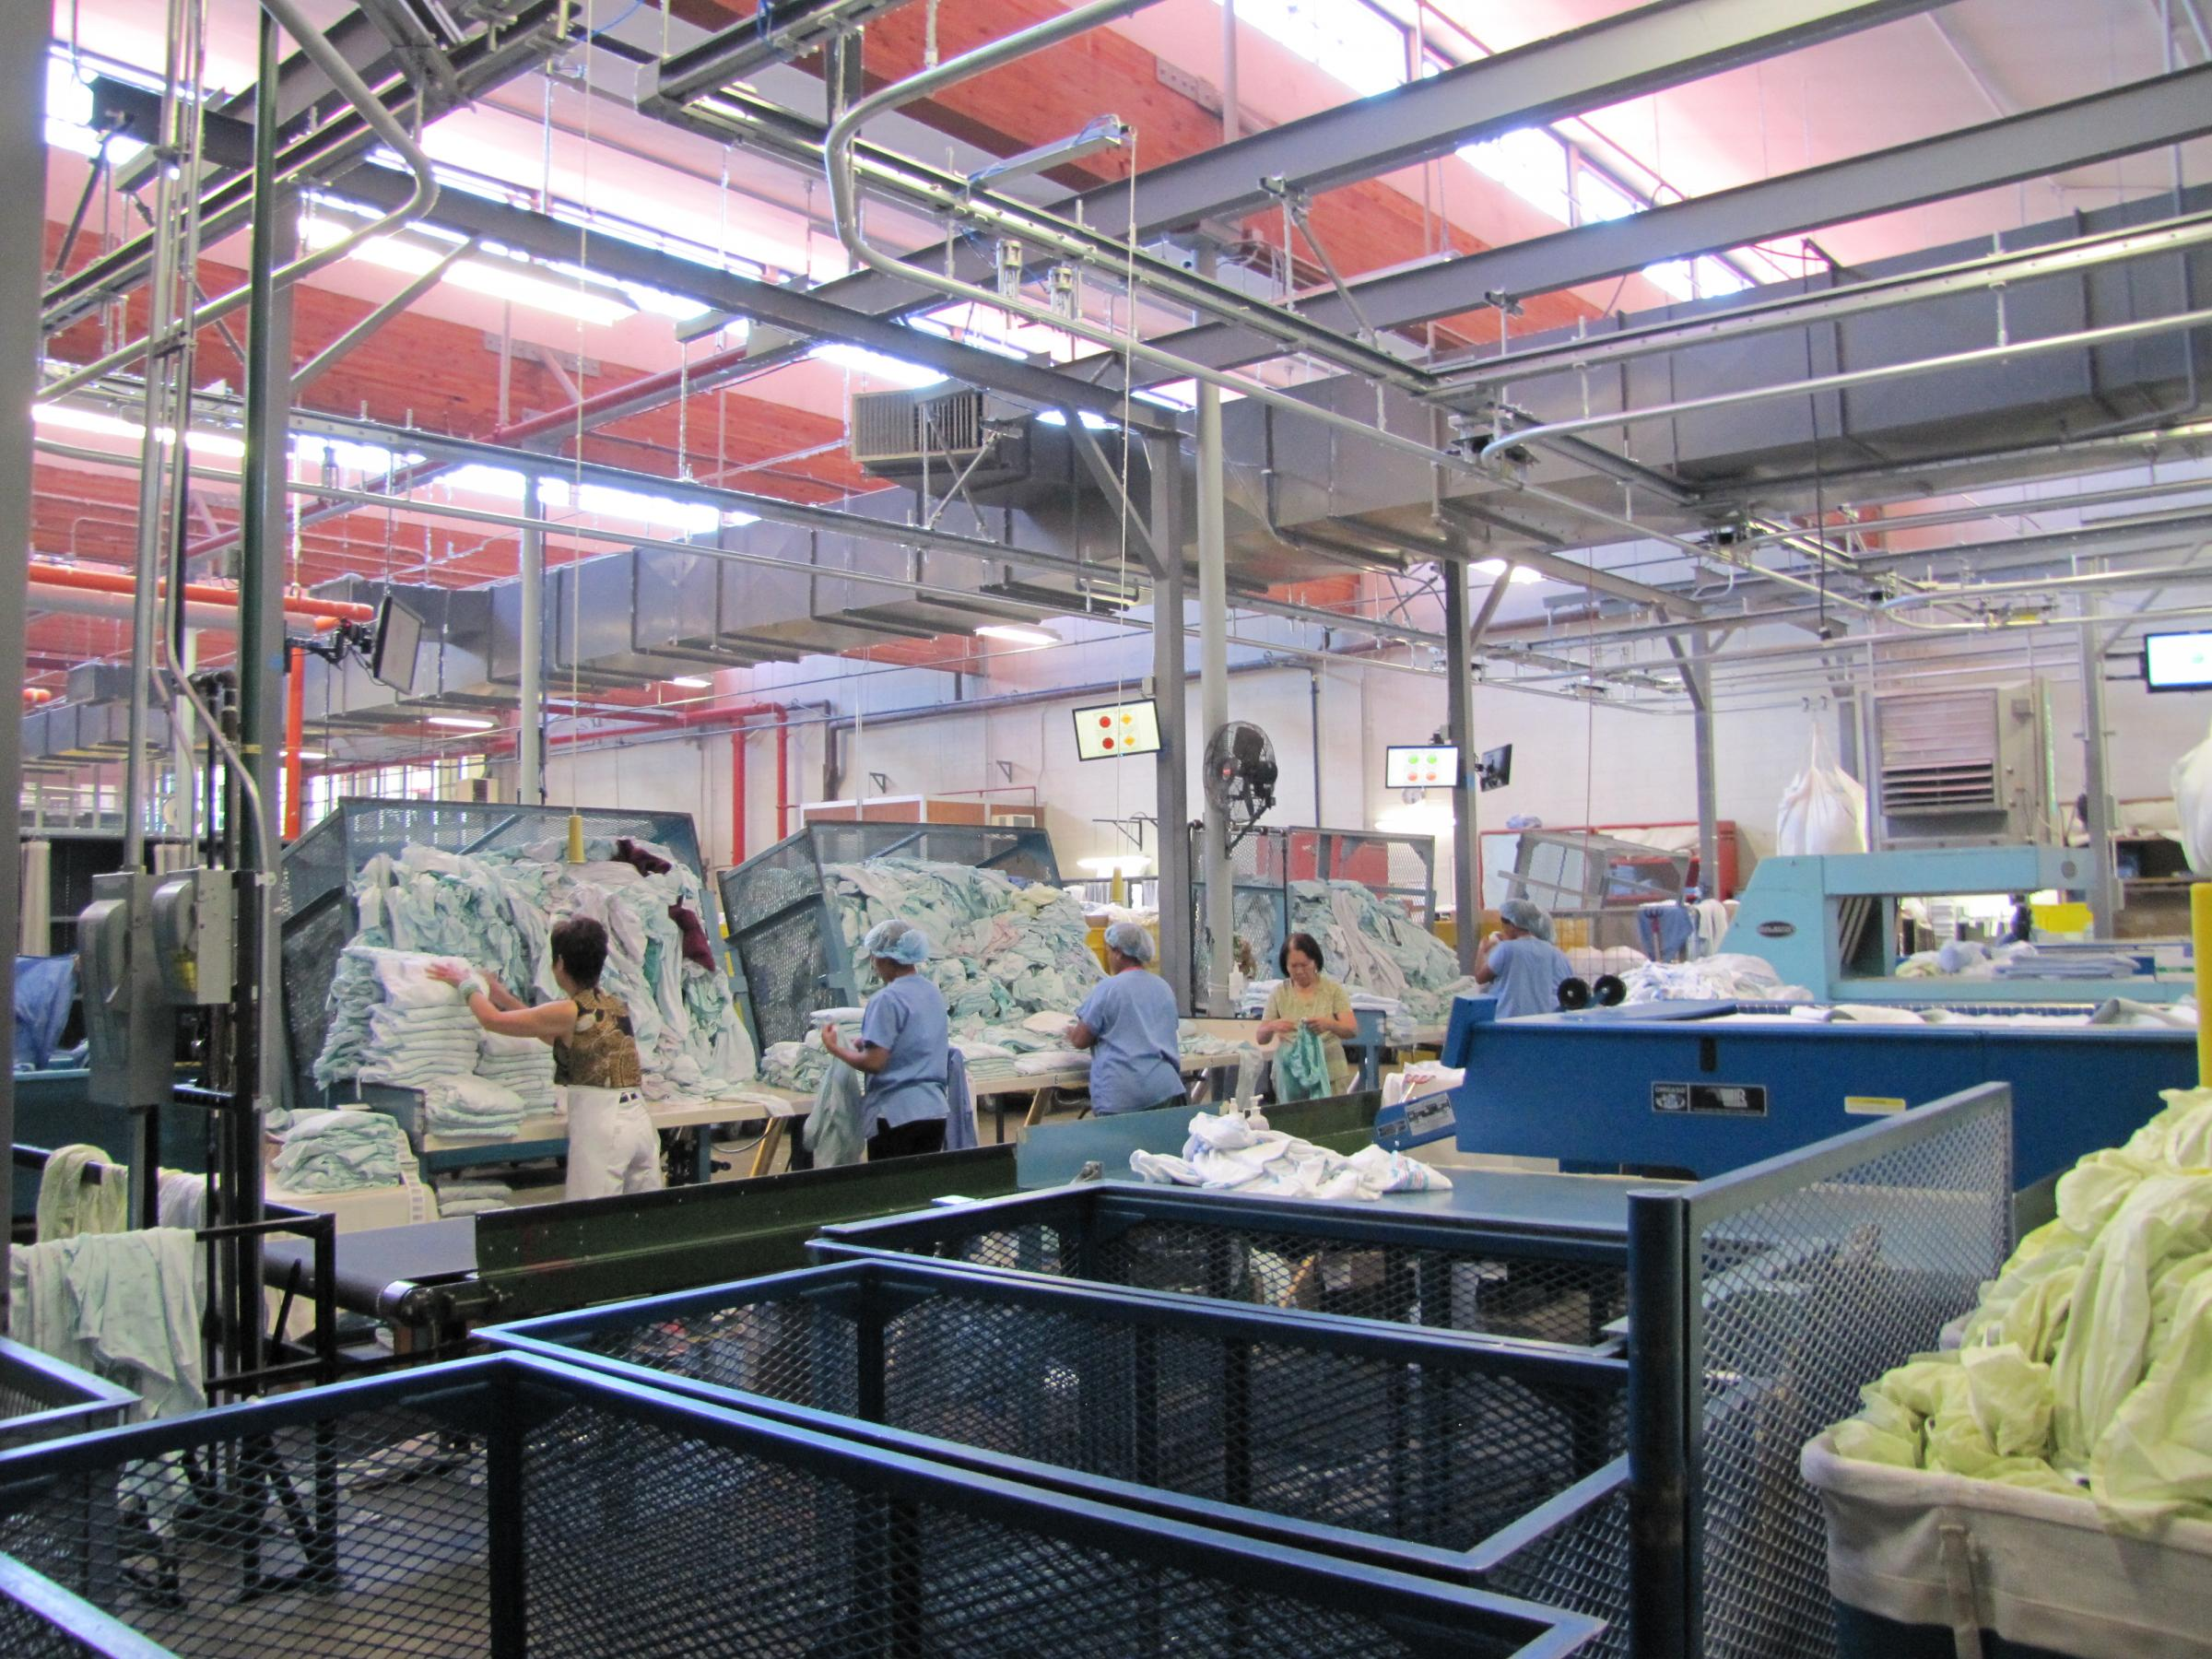
In the Mount Baker neighborhood, there is potential for a small DES that would utilize the waste heat produced by the UW Consolidated Laundry facility in the neighborhood to provide energy for adjacent buildings and the laundry facility.

What has already been done?

Between 2009 and 2011, a few studies were conducted to give a basic analysis of the feasibility of a DES using waste heat recovery technology for district heating. These studies were intended to be used to inform the discussion around a DES in Mt. Baker and are not near a complete evaluation of the system’s feasibility. Initial stakeholders involved in the exploration of a Mt. Baker DES were Sound Transit, UW Laundry, City of Seattle, Paladino and Co., and Heartland LLC.

Key Findings

What were the main conclusions?

A common conclusion of the feasibility analysis are that further studies should be conducted to determine if a DES is truly a viable option for Mt. Baker at this moment in time. A more detailed analysis of several components of the DES, including the business case, legal arrangements, anticipated growth, and system capacity must be examined for a DES to move forward. Further economic analysis is required to determine whether an energy provider can generate energy at an economical rate for the UW Laundry given the required capital investment for the system and UW Laundry’s infrastructure investment while further investigation into specific legal arrangements is necessary for establishing a district energy utility. Unfortunately, discussions between Sound Transit, UW, and the City of Seattle, were not able to determine who would sponsor further analysis.
Although the studies were generally inconclusive, some rough estimates, potential barriers, and further recommendations were identified. A basic analysis prepared by Affiliated Engineers estimated that the construction cost for various heating systems ranged from $90,000 to $950,000 per building. These were rough estimates that were based on assumptions such as future development of buildings, energy demands, and cost of electricity and exemplifies the current uncertainty around what specific system is best suited for the DES project and at what cost. Two major potential barriers that were identified are the uncertainty of future development, including associated density and building type, and procuring capital to support the project. Uncertainty around future development may be reduced by examining anticipated growth projections in the Property Assessment section. One potential barrier related to future development is the willingness of developers of adjacent parcels to sign power purchase agreements, authorizing participation in the DES.
In terms of identifying a funding source for the project, the analysis prepared by Paladino suggests looking to incentives that come from policies such as an incentive offered by utilities under conservation and alleviated infrastructure development programs. State and federal grants and loans, such as those offered by the U.S. Department of Energy and the EPA can also support the funding of the DES. The local government could also play a more central role in supporting a DES by providing financial tools, such as subsidies, as well as implementing policies that incentivize and streamline district energy projects.
In order to move forward with the DES in the Mount Baker neighborhood, the immediate recommendation is to upgrade the current steam generation equipment at UW Consolidated Laundry. According to the analysis prepared by Paladino and Co., although there are energy efficiency opportunities using the waste heat at the UW Consolidated Laundry, given the age and efficiency of the current steam generation equipment, it is not recommended to serve as a standalone energy generator without efficiency upgrades or infrastructure replacement. Further detailed feasibility studies should be pursued once UW Laundry takes actions to upgrade their infrastructure. Sound Transit, UW, and the City of Seattle continue to remain committed to exploring and participating in a district energy system at the Mt. Baker Station area so long as an efficiency upgrade process at the UW laundry begins. Without such upgrades, a DES is very unlikely to be cost effective.

What other options are there?

Beyond energy savings opportunities specific to a DES centered at the UW Laundry facility, there is opportunity for UW laundry to capture waste heat to improve the efficiency of their boilers. This would be an internal energy savings project and may be eligible for incentives offered by the utility but would not be considered a district energy project. More broadly speaking, energy savings can be pursued at multiple scales and through multiple avenues. Immediate attainable opportunities in terms of building energy efficiency are appliance and building retrofits such as window and insulation upgrades. Seattle City Light offers free home energy audits for those who qualify and rebates for various retrofits and appliances.
Options more directly aimed to meet the Living Building Certification feature of the Living Community Challenge should address renewable energy production. The Net Zero Energy Building Certification requires that energy needs be met with on site renewable energy production. The most common form of urban on site energy production is solar power but wind power is also an option. A home solar electric system is estimated to cost between $9,000-$15,000, have a payback period of 10-15 years depending on the system, and come with various incentive and financing programs. The systems are also generally maintenance free so no maintenance costs are required. Larger systems, for commercial buildings for example, will cost more but have shorter payback periods.
Perhaps the most attractive solar energy option for the Mount Baker neighborhood is participation in a community solar program offered by Seattle City Light. A community solar program works in a similar way that a community garden works. Those who do not own property or do not have the space on their property to have a garden, or in this case solar panels, can purchase a share of an offsite project in the community and receive benefits. Several community solar projects exist in Seattle including ones in Jefferson Park, Phinney Ridge, and the Seattle Aquarium. All community solar shares are currently sold out but collaboration with Seattle City Light to establish a community solar project in Mount Baker neighborhood is encouraged. A properly placed community solar project could meet the onsite renewable energy production requirement of the living building challenge.
Supporting off site renewable energy projects is also an option. Although this wouldn’t go towards meeting the onsite renewable energy production requirement, supporting off site renewable energy is still a positive way for the community to add renewable energy to the power grid. One way to do this is through the Green Up program offered by Seattle City Light. Residents and businesses of Mount Baker can purchase renewable energy credits (RECs), essentially matching their energy usage with renewable energy that is produced by independent renewable energy projects in the northwest. The program offers different participation levels, is included in the participants’ electricity bill, and is generally considered to be affordable.

Application to Mt. Baker Neighborhood

What is its role in Mount Baker neighborhood?

A district energy system utilizing UW Laundry’s waste heat would be a positive addition to the Mount Baker neighborhood. However, the benefits of a DES would not directly benefit the community members of Mount Baker, except for future residents of future developments participating in the DES. Community awareness and support for the project can be increased through a larger outreach and marketing effort. Efforts should address who is sponsoring the project as well as the economic and environmental benefits. Being clear about where the funds for the project came from and why is important for members of the community to not feel marginalized or left out of money which they perceive to be better spent somewhere else.

What role does it play in the Living Community Challenge?

The district energy project utilizing the waste heat of UW Laundry would not qualify for the net zero energy building requirement of the Living Building Challenge due to the lack of production of renewable energy. However, working to increase energy efficiency is still a valuable goal that should be pursued. Community awareness of this project would also encourage further pursuits of energy efficiency and sustainable energy production.

"What Is District Energy?" DISTRICT ENERGY INITIATIVE. Accessed November 16, 2016. http://districtenergyinitiative.org/.
Jun 7, 2013 By STEVE TREDINNICK, PE, CEM; Syska Hennessy Group; Madison, Wis. | HPAC Engineering. "Why Is District Energy Not More Prevalent in the U.S.?" Heating Piping Air Conditioning Engineering. Accessed November 16, 2016. http://hpac.com/heating/why-district-energy-not-more-prevalent-us.
Seidman, Karl F., and Drew Pierson. Financing Urban District Energy Systems: Trends and Implications for Portland. PDF. Massachusetts Institute of Technology, Community Innovators Lab, January 2013.
District Energy in Cities. PDF. Paris: United Nations Environment Programme, 2015.
Seidman, Karl F., and Drew Pierson. Financing Urban District Energy Systems: Trends and Implications for Portland. PDF. Massachusetts Institute of Technology, Community Innovators Lab, January 2013.
Mt. Baker Station Area Steam District Energy System Demand Side Analysis. PDF. Seattle: Affiliated Engineers Inc., January 13, 2009.
Sound Transit District Energy Feasibility Analysis. PDF. Seattle: Paladino and Company, May 21, 2010.
Mt. Baker Station Area Steam District Energy System Demand Side Analysis. PDF. Seattle: Affiliated Engineers Inc., January 13, 2009.
City of Seattle - District Energy Pre-Feasibility Study. PDF. Seattle: Affiliated Engineers Inc., September 22, 2011.
Sound Transit District Energy Feasibility Analysis. PDF. Seattle: Paladino and Company, May 21, 2010.
District Energy in Cities. PDF. Paris: United Nations Environment Programme, 2015.
Sound Transit District Energy Feasibility Analysis. PDF. Seattle: Paladino and Company, May 21, 2010.
Sound Transit District Energy Feasibility Analysis. PDF. Seattle: Paladino and Company, May 21, 2010.
Living Community Challenge. PDF. Seattle: International Living Future Institute, 2016.
"Net Zero Energy Buildings." Net Zero Energy Buildings | Whole Building Design Guide. December 16, 2014. Accessed November 22, 2016. https://www.wbdg.org/resources/netzeroenergybuildings.php.
"Solar Energy FAQ." http://www.seattle.gov/light/solarenergy/solarfaq.asp#cost.
NWWindandSolar. "Frequently Asked Questions." NW Wind & Solar. Accessed November 22, 2016. http://www.nwwindandsolar.com/residential-solar-power/faqs/.
"Community Solar." Seattle City Light | Solar Energy | Community Solar. Accessed November 22, 2016. http://www.seattle.gov/light/solarenergy/commsolar.asp.
"Green Up FAQ." Seattle City Light | Green Up | FAQ. Accessed November 22, 2016. http://www.seattle.gov/light/Greenup/faq.asp.

